Topic table

style 1

|  |  |  |  |  |  |  |  |  |  |
| --- | --- | --- | --- | --- | --- | --- | --- | --- | --- |
|  |  |  |  |  |  |  |  |  |  |

|  |  |  |  |  |  |  |  |  |  |  |  |  |  |  |  |  |  |  |  |  |  |  |  |  |  |  |  |  |  |  |  |  |
| --- | --- | --- | --- | --- | --- | --- | --- | --- | --- | --- | --- | --- | --- | --- | --- | --- | --- | --- | --- | --- | --- | --- | --- | --- | --- | --- | --- | --- | --- | --- | --- | --- |
|  |  |  |  |  |  |  | |  | |  | | | | |  | | |  | | |  | | |  | | |  | | |  | | |
|  | |  |  | | | |  | | | | | |  | | |  | | |  | | |  | | |  | | |  | | |
|  | |  |  | | | |  | | | | | |  | | |  | | |  | | |  | | |  | | |  | | |
|  | |  |  | | | |  | |  | |  |  | |  | | |  | | |  | | |  | | |  | | |  | | |
|  | |  | |  |  | |
|  | |  | |  |  | |
|  | |  | |  |  | |
|  | |  | |  |  | |
|  | |  |  | | | |  | | | | | |  | | |  | | |  | | |  | | |  | | |  | | |

|  |  |  |  |  |  |  |
| --- | --- | --- | --- | --- | --- | --- |
|  |  |  |  |  |  |  |
|  |  |  | hgfhfg |  |  |  |
|  |  |  | gtrt |  |  |  |
|  |  |  |  |  |  |  |
|  |  |  |  |  |  |  |

|  |  |  |  |  |  |  |
| --- | --- | --- | --- | --- | --- | --- |
| |  | | --- | |  |  |  | | --- | |  |  |  | | --- | |  | | |  | | --- | | hfghrthrt |   ytyhth | |   hhh |

|  |  |
| --- | --- |
|  | |
| style 2 | |

style 3

]

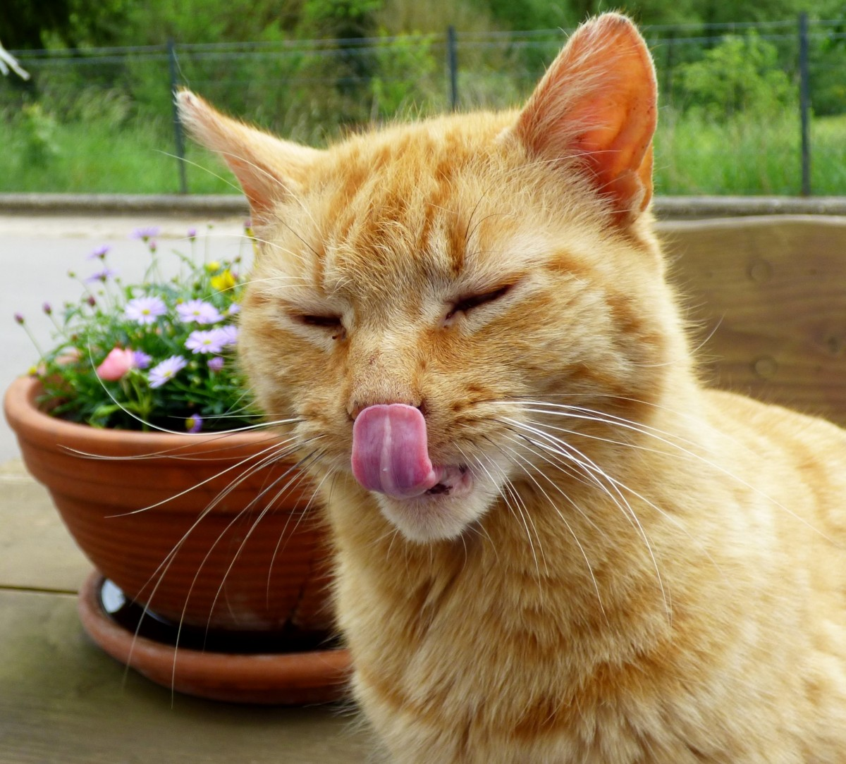

ghjgjgjjgytj  
lkjlkjlkjlkl

jlkl

l;lkj;jklk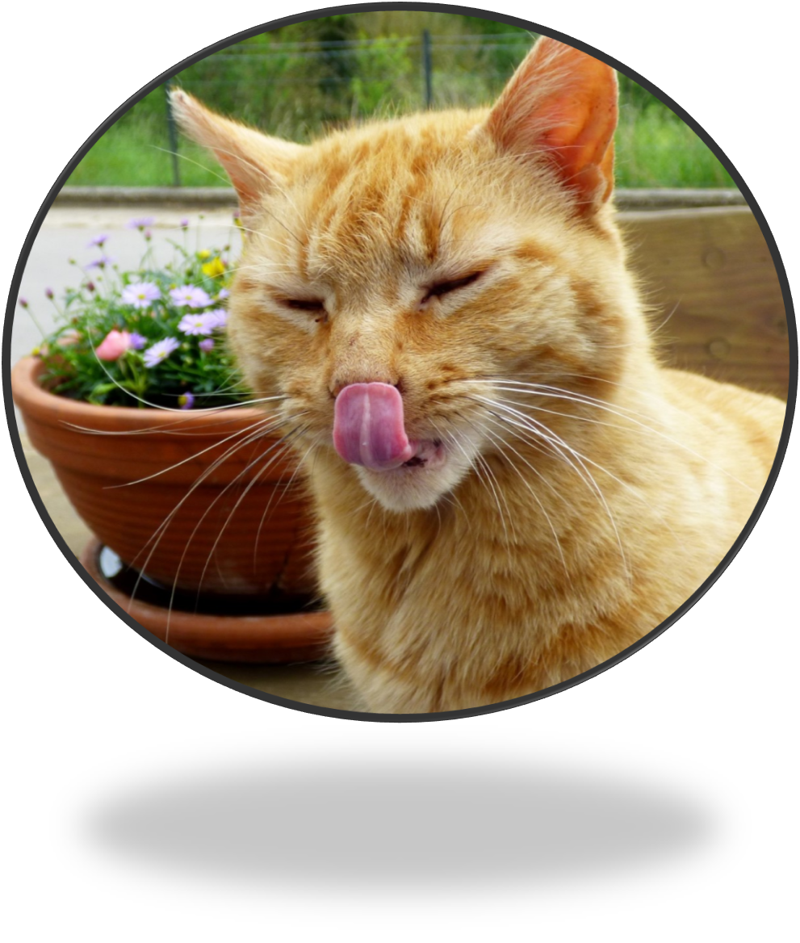

tghhhhhhh



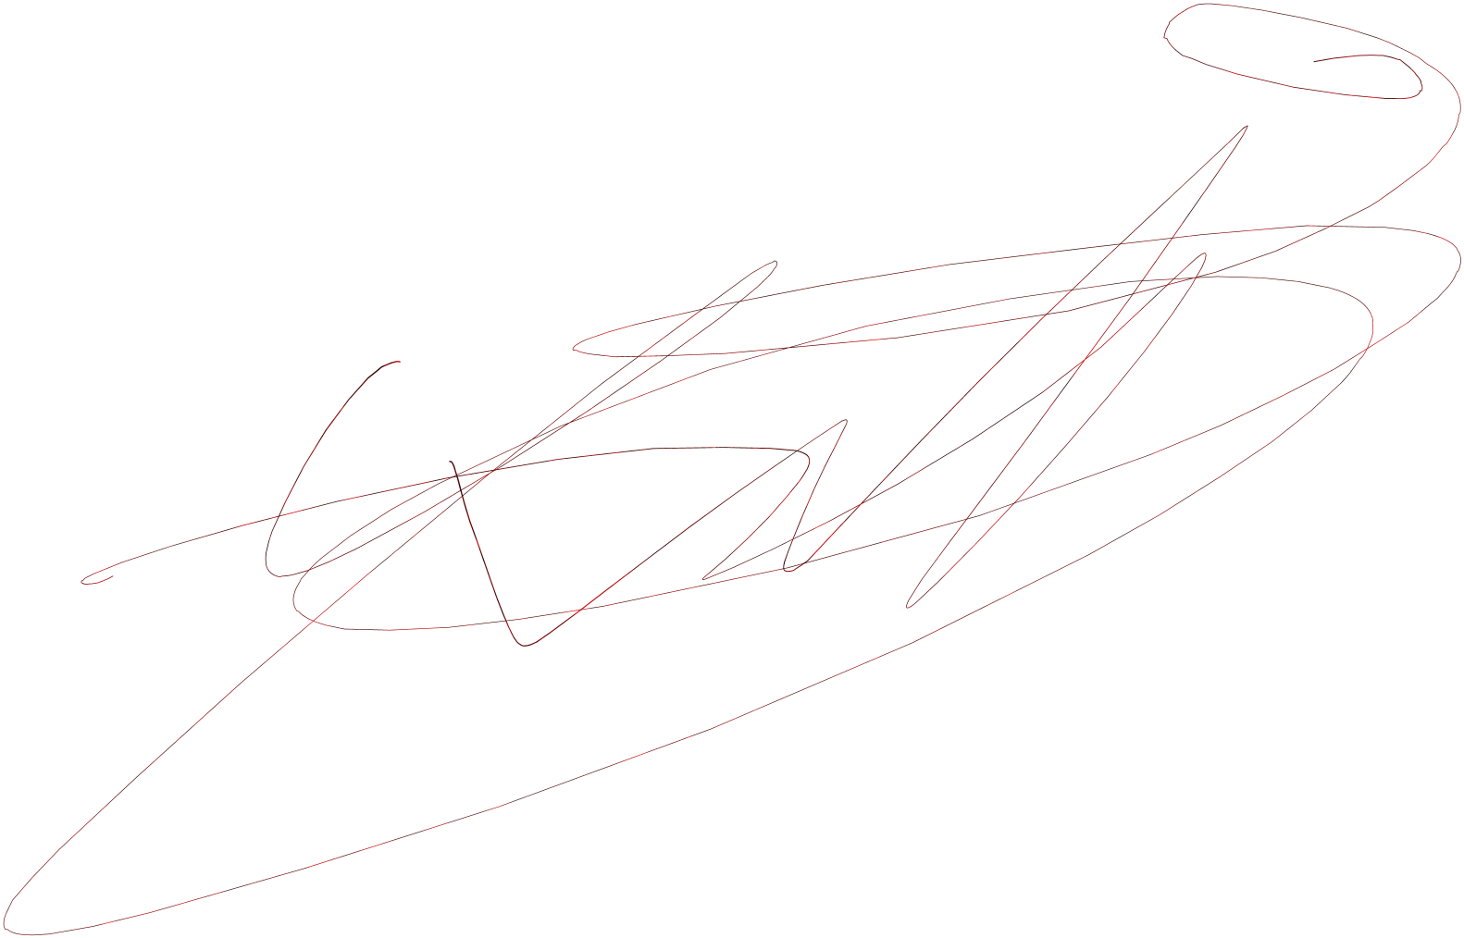

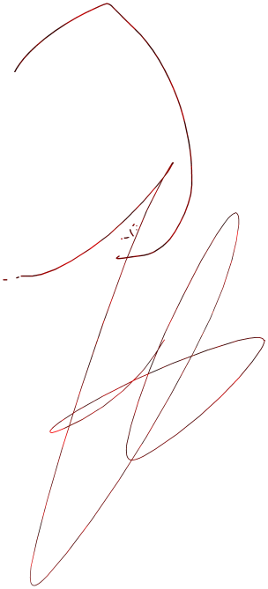uuyuytuyu



u

y

nghnnnnbnghnghhl

gfyfy,kmljghfgh